**MacOS installation** **1**

**Windows installation** **8**

# MacOS installation

<https://www.anaconda.com/products/individual#download-section>

Download below software

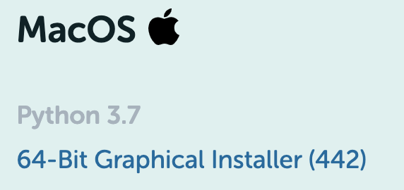

Go to your downloads folder, click Install

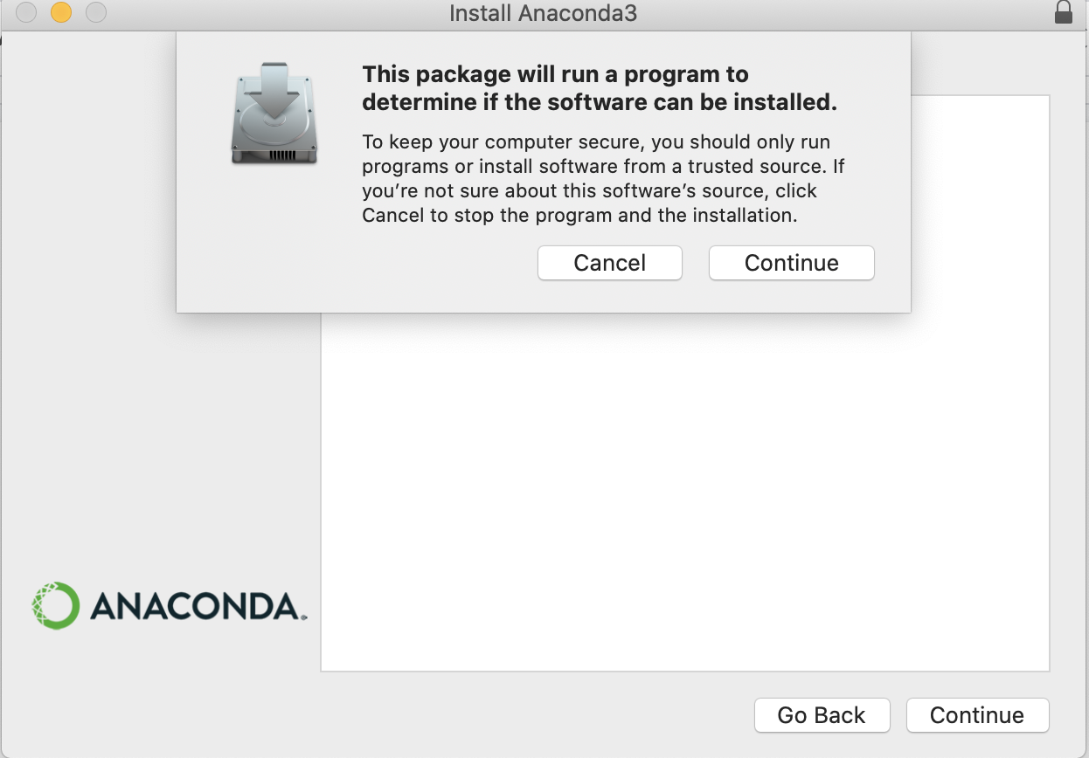

Continue to see Introduction screen → continue to ReadMe → Read and risk accept License Agreement

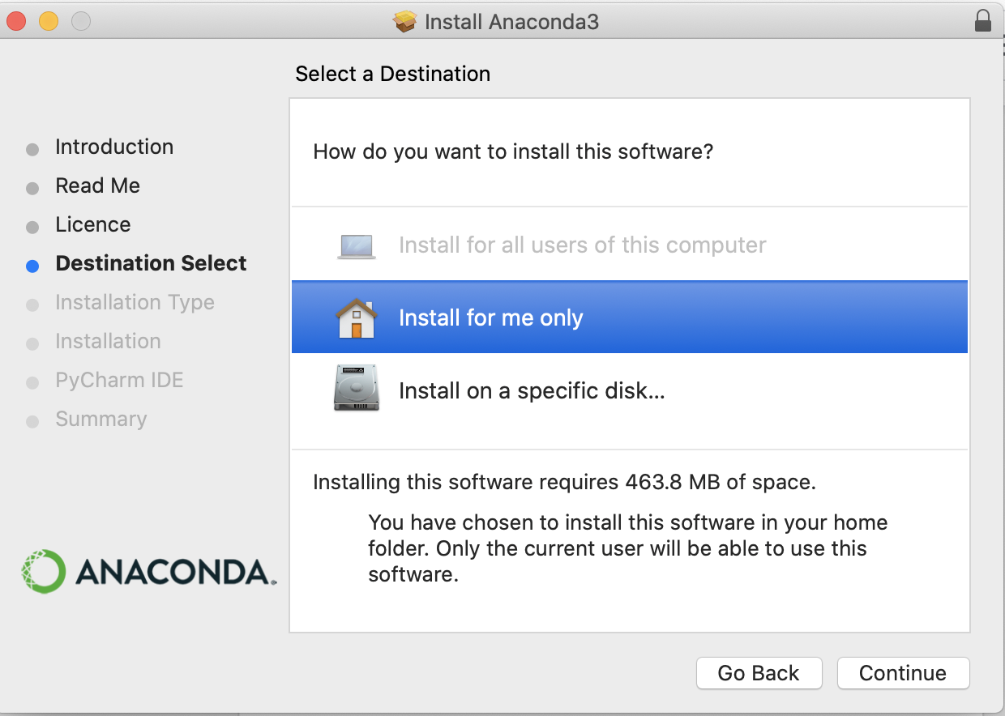

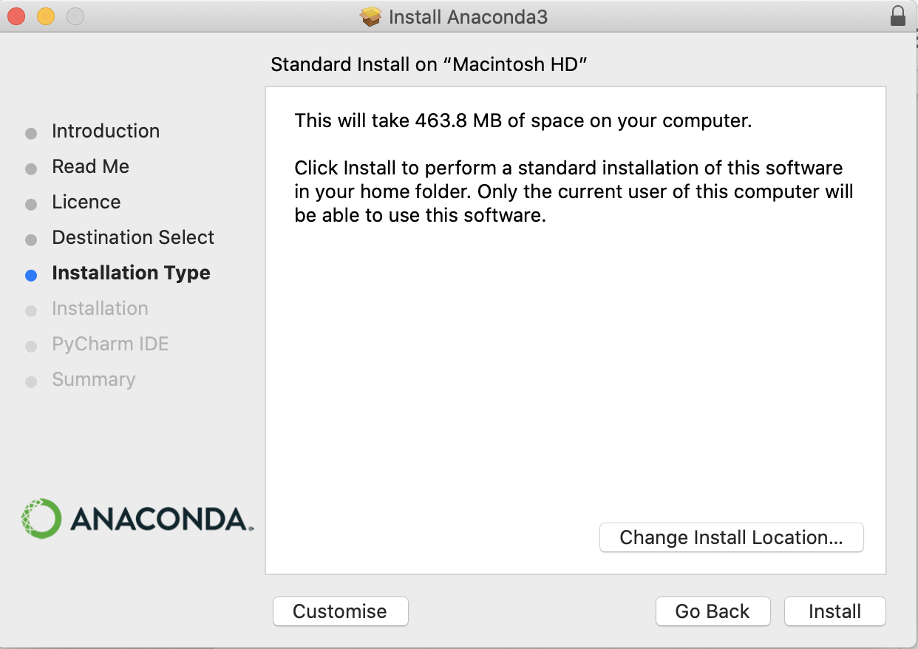

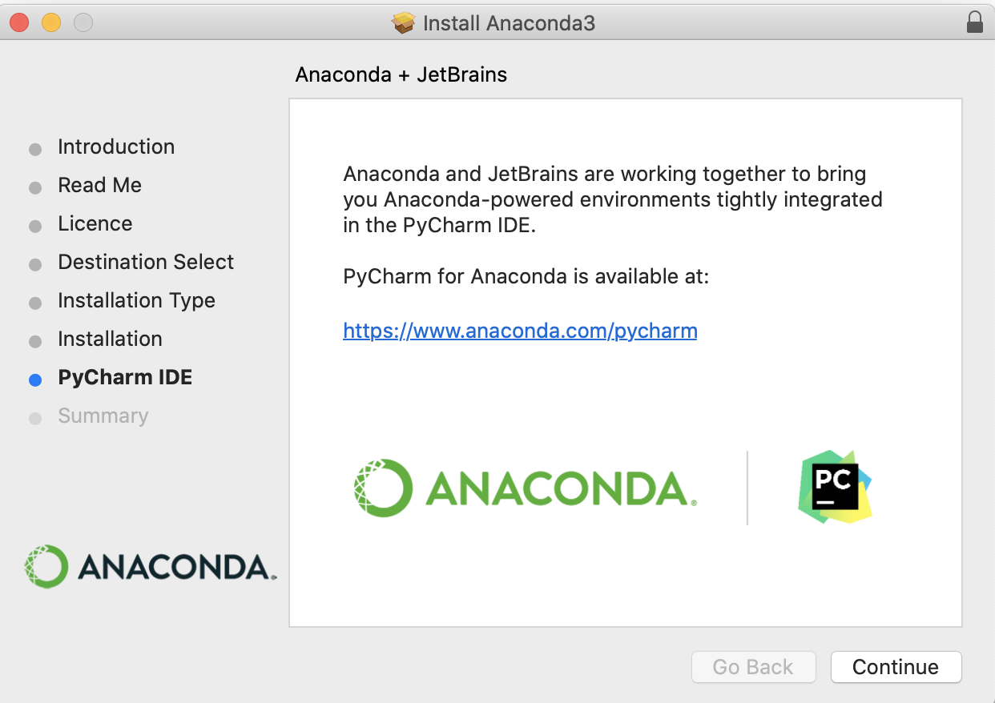

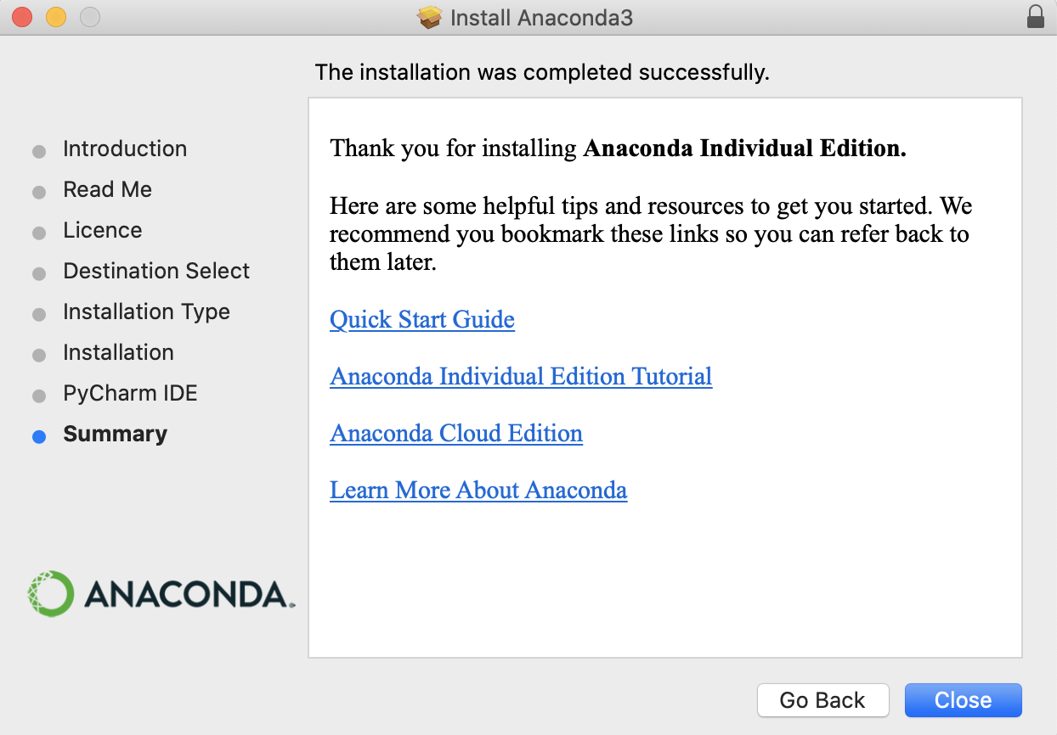

Congratulations, your installation is successful !

Open Launchpad, then click the Anaconda Navigator icon.



After 15-20 seconds, below screen pops up

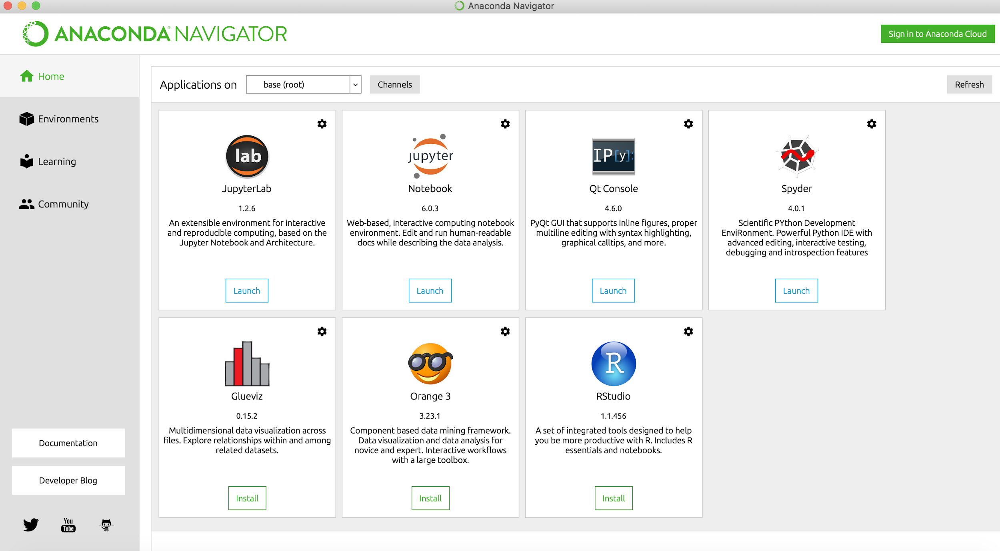

Click Launch on Jupyter

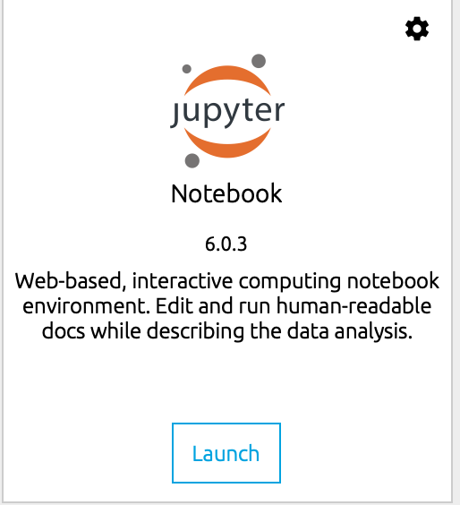

After a few seconds, on your default browser the following webpage should open up.

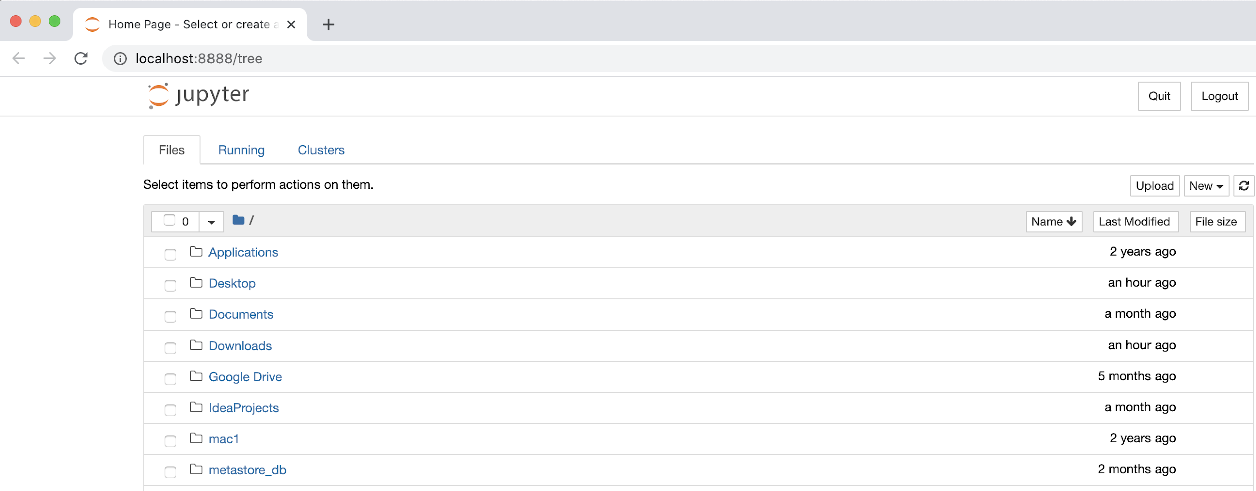

Congratulations ! You have successfully tested the installation !

# Windows installation

Go to <https://www.anaconda.com/products/individual#download-section>

Download below software

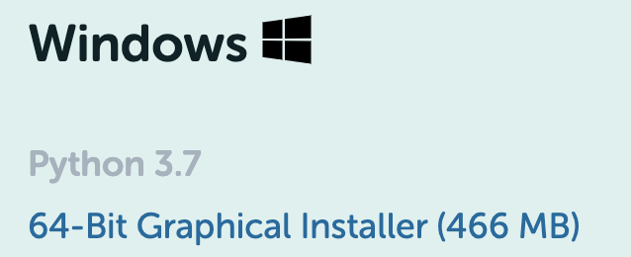

Go to your downloads folder, click Install

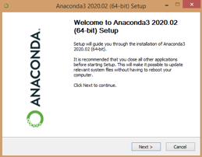

Agree license agreement → Install Just me → Choose install location to an empty directory

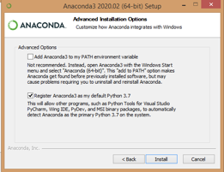

Click Install

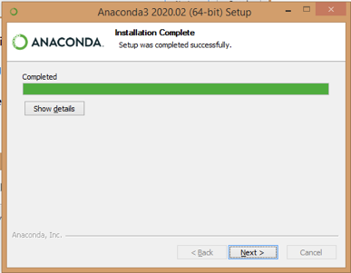

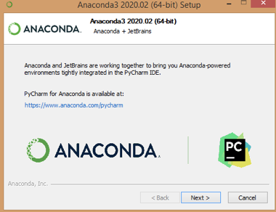

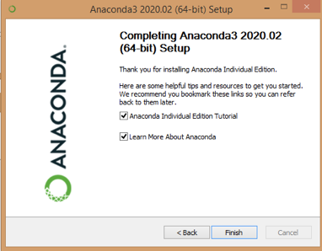

Congratulations ! Your installation is successful

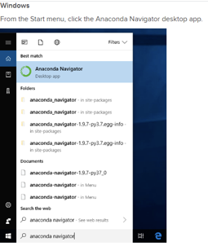

After 15-20 seconds, below screen pops up

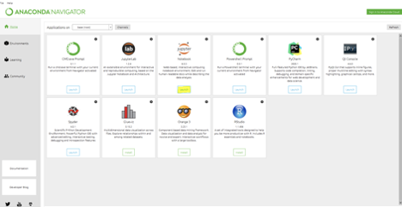

Click on Launch button on Jupyter Notebook

After a few seconds, on your default browser the following webpage should open up.



Congratulations ! You have successfully tested the installation !